-------------------------------IMPORTANT---------------------------
When at home, connected to your home network, visit – http://intranet.wmc.ac.uk/ip.php - and email the resulting IP address to it.team@wmc.ac.uk.
We can then update the firewall to grant you access to remote access.
----------------------------------------------------------------------------
Press the Windows key (looks like a little Windows symbol) + R
In the Run box type MSTSC and press enter.
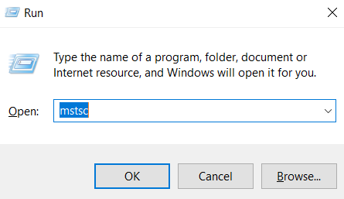
This brings up the Remote Desktop Connection box.
Enter REMOTE.WMC.AC.UK and click on Connect
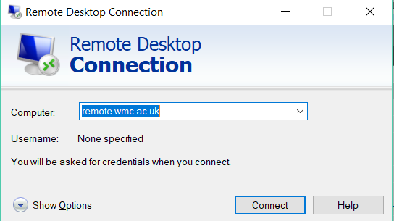
You’ll get one of the following boxes depending on which version of Windows you are using.
Windows 8/10
Click on More choices
Click on Use a different account. At the top of the box enter your college username and password. Precede your username with WMC\. Tick the Remember me box.

Tick the Don’t ask me again for connections to this computer box and click Yes to accept the certificate.
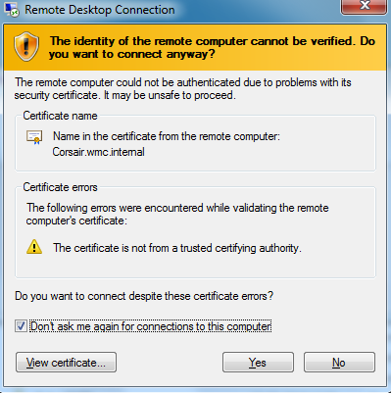
You should now be connected to the college through remote access. Login as you normally would.
